CSIR-CMERI develops World’s Largest Solar Tree
CSIR-CMERI has developed the World’s Largest Solar Tree, which is installed at CSIR-CMERI Residential Colony, Durgapur. Prof.(Dr.) Harish Hirani, Director, CSIR-CMERI, while elaborating about the technology stated that, “The installed capacity of the Solar Tree is above 11.5 kWp. It has the annual capacity to generate 12,000-14,000 units of Clean and Green Power”.

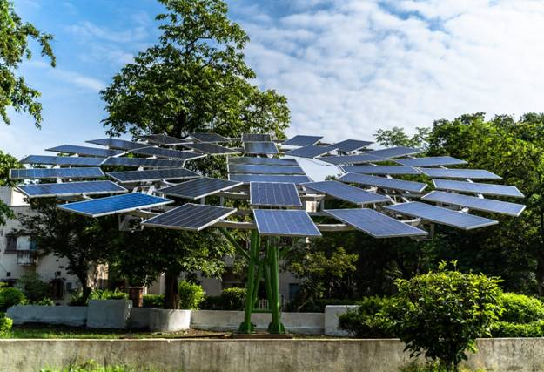

The Solar Tree has been designed in a manner to ensure maximum exposure of each Solar PV Panel to Sunlight and also creation of the least amount of shadow area beneath. There are a total of 35 Solar PV Panels in each tree with a capacity of 330 wp each. The inclination of the arms holding the Solar PV Panels are flexible and can be adjusted as per requirement, this feature is not available in Roof-Mounted Solar facilities. The energy generation data can be monitored either real-time or on daily basis.

Prof.(Dr.) Harish Hirani explained, “The CSIR-CMERI developed Solar Tree besides being the World’s Largest Solar Tree also has certain customizable features for application at diverse sites. The Solar Trees were designed in a manner to ensure minimum Shadow Area, thus potentially making these Solar Trees available for widespread usage in Agricultural activities such as High Capacity Pumps, e-Tractors and e-Power Tillers.
TheseSolar Trees can be aligned with Agriculture for substituting price-volatile fossil fuels. Each Solar Tree has the potential to save 10-12 tons of CO₂ emissions being released into the atmosphere as Greenhouse Gases when compared with fossil fuel fired energy generation.Besides, the surplus generated power can be fed into an Energy Grid.

This Agricultural Model can provide a consistent economic return and help the farmers counter the effects of the uncertain variations in Agriculture related activities, thus, making farming an Economic and Energy Sustainable practice.”

Each Solar Tree will cost Rs 7.5 lakhs and the interested MSMEs can align their Business Model with the Pradhan Mantri Kisan Urja Suraksha evem Utthan Mahabhiyan (PM KUSUM) Scheme for farmers, for developing a Renewable Energy based Energy Grid.

The solar tree has the capability to incorporate IOT based features, i.e. round-the-clock CCTV surveillance in agricultural fields, real-time humidity, wind speed, rainfall prediction and soil analytics sensors. The CSIR-CMERI developed solar powered e-Suvidha Kiosks may also be connected to the Solar Trees for real-time access to the vast majority of agricultural database as well as to the eNAM i.e. National Agricultural MarketPlace for instant and real-time access to an unified online market.This Solar Tree is a Quantum Leap towards making an Energy Reliant and Carbon Negative India.

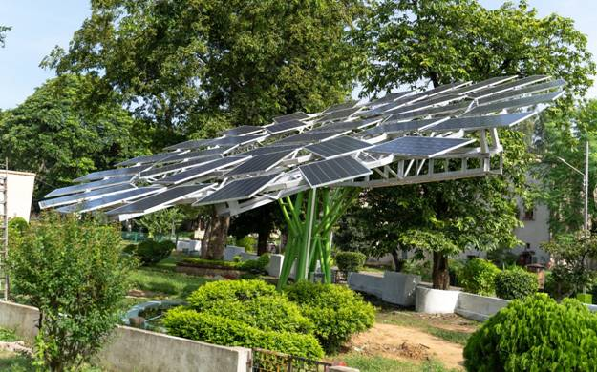

Source
Press Information Bureau, 31 August, 2020

