CSIR-CMERI develops Sustainable Municipal Solid Waste Processing Facility

“Besides achieving Decentralised Decimation of Solid Wastes, it also helps create value-added end-products”: Prof. (Dr.) Harish Hirani
Equipped with Advanced Segregation techniques, the Bio-Digestion process adopted has minimum pollution factor
This CSIR-CMERI MSW Technology envisions a Zero-Landfill and a Zero Waste City in addition to developing Job-Creation opportunities

The changing ecological scenarios requires special attention to address the issue of ‘Sustainable Processing of Municipal Solid Waste’. This is not only a necessary component of converting waste into useful end products but also to maintain a cleaner environment and to safeguard contamination of soil, air and water.

To throw more light on the subject, Prof. (Dr.) Harish Hirani, Director, CSIR-CMERI, Durgapur, deliberated on the issue in his Keynote address at programme ‘KrishiJagran’, live-streamed on its Facebook Page on Saturday. He charted out the historical development of traditional Waste Processing Techniques and demonstrated how the present scenario demands special customized attention towards the processing of Municipal Solid Wastes.

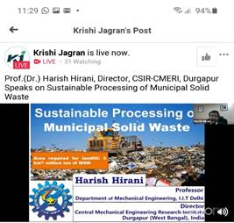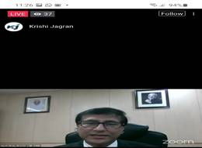

Prof. Hirani said that “Ineffective processing of Wastes are the root of all diseases as the dumped Landfills become the Contamination Hubs for Pathogens, Bacteria and Viruses. Besides, they also become the cauldron for emission of Methane Gas, especially during the churning mechanisms deployed during Composting processes. Composting also does not yield impactful economic returns for the entrepreneurs. The mixed nature of wastes in the current scenario can easily lead to infiltration of heavy metals into agricultural produce, through the indiscriminate creation of Composts. The CSIR-CMERI developed Municipal Solid Waste Processing Facility has not only helped achieving Decentralised Decimation of Solid Wastes, but has also helped create value-added end-products from abundantly available redundant stuffs such as Dry Leaves, Dry Grass etc. The primary focus of CSIR-CMERI is to unburden the common households from the segregation responsibilities through Advanced Segregation techniques. The Bio-Digestion process adopted has minimum pollution factor. The MSW facility has been equipped with special capabilities to deal with a diverse range of waste including Masks, Sanitary Napkins, Diapers etc. The MSW facility has been with special disinfection capabilities to help Break the COVID Chain through UV-C Lights and Hot-Air Convection methods. We have also achieved optimum Energy Sufficiency in the MSW facility by adding the Solar energy technology, which can also feed the surplus Energy Supply onto a Mini-Grid.”

“Decentralised Waste Management technology developed by CSIR-CMERI can result in drastic reduction of expenditure related to Transportation Logistics and can help reductions in CO₂ emissions, by reducing fossil fuel usage. The Scientifically Decentralised Waste Processing Hubs will help multiply outreach for various locations and will also boost the manufacturing potential for the residents of the region. This CSIR-CMERI MSW Technology envisions a Zero-Landfill and a Zero Waste City in addition to developing Job-Creation opportunities. This technology will also help create a revived Green Energy reliant India”.

The Institute developed Solid Waste Disposal using Plasma Arc converting wastes into plasma state for proper disposal. The residues generated having good carbon content are used in agriculture as fertilizer and non-usable are utilized to make bricks for construction purposes. Thus, it is creating wealth out of wastes through use of science. The technology pertains to the period 2013-16 and has some cost constraints. Thus, another solution provided by CSIR-CMERI which is more cost effective is Mechanized Segregation Process. The existing Windrow Composting procedure has some drawback as it requires more land space, pasteurization is required for effective disinfection, it is labour intensive and has restricted utilization due to presence of heavy metals. During the rainy season its management is difficult due to presence of moisture. The alternative solution is Bio-methanation Plant. CSIR-CMERI has started an innovative technology of producing the Biogas from grass and weeds and Vermi-composting of Slurry of the plant process. A mechanized system has been developed to utilize saw dust, shredded leaves, biogas slurry and produces briquettes. The Smokeless Stove has also been developed to utilize these briquettes. Such stoves have the benefits of Reduction in import of LPG and reduction in pollution.

Towards targeting a Zero landfill, the latest technology being used by Institute is Pyrolysis process wherein conversion of plastics into gas and fuel are done. This is an environment-friendly process and produces within permissible toxins as conversion happens in the anaerobic chamber. Heavy oil, gas being used in pyrolysis helps in obtaining self-sustainability. Through Plasma Gasification Process also eco-friendly disposal of solid wastes is processed without formation and reformation of toxic dioxins and furans. The Decentralized Solid Waste Management Plant developed by CSIR-CMERI has all the potentials to managing any contaminants available in the wastes.

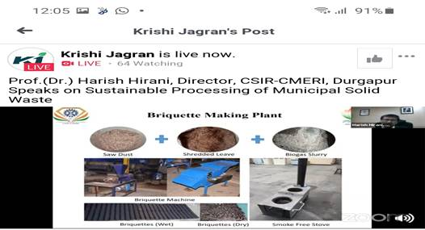

Source
Press Information Bureau, 18 October, 2020

