Dr. Harsh Vardhan inaugurates Centre for Advanced Radiation Shielding and Geopolymeric Materials and an Analytical High Resolution Transmission Electron Microscope Laboratory at CSIR-AMPRI, Bhopal

Dr. Harsh Vardhan also lays Foundation Stone of CSIR-AMPRI Bamboo Composite Structure
The Minister of Science & Technology, Earth Sciences and Health & Family Welfare, Dr. Harsh Vardhan, has said that CSIR-AMPRI has been successfully adopting ‘Waste to Wealth’ strategy as the institute has developed radiation shielding materials utilizing industrial wastes as raw materials.Significantly , a novel process for making lead free and highly effective shielding materials useful for the construction of X-ray diagnostic and CT scanner room has been developed utilizing industrial waste namely red mud and fly ash.
He was inaugurating the Centre for Advanced Radiation Shielding and Geopolymeric Materials and Analytical High-Resolution Transmission Electron Microscope Laboratory, during his visit to CSIR constituent lab AMPRI based in Bhopal on March 13, 2021. He also laid the foundation stone of CSIR-AMPRI Bamboo Composite Structure.
The Minister pointed out that the Institute is working in the cutting-edge areas of advanced technologies . It is in the forefront during the pandemic time by undertaking research in collaboration with AIIMS, Bhopal in the area of development of rapid electrochemical based diagnostic for detection of SARS-COV infection.

Various geopolymeric materials were also developed by CSIR-AMPRI utilizing Coal based Thermal Power Plant waste i.e. Fly-Ash and three US patents have been granted on geopolymeric materials.
A unique Centre for Advanced Radiation Shielding and Geopolymeric Materials with a total area of 455.52 Sq.m and Carpet Area of 906.24 Sq.m is being established. The advances in geopolymeric materials will accelerate strategic applications such as development of Thermal Resistant Geopolymeric Concrete for Missile /Rocket Launching Pad and development of Geopolymeric Bullet Proof Concrete for Bunkers; development of Graphene-Induced Geopolymeric Concrete and Geopolymeric Radiation Shielding Concrete. In addition, it will also have advanced conventional applications such as development and upscaling of ready mix Geopolymeric Concrete for road applications and structural applications; development of Roller-Compacted Geopolymeric Concrete and development of pre-stressed Geopolymeric Concrete components.

Dr Harsh Vardhan expressed the hope that the Centre will enhance the knowledge for understanding the mechanism of Radiation Shielding and improvement in engineering properties of developed materials. It will facilitate the upscaling of technologies in this area and provide technological support to Indian industry. Reiterating the “Waste to Wealth” theme, Dr Harsh Vardhan also released the fly ash compendium.

Another major facility inaugurated by Dr Harsh Vardhan at CSIR-AMPRI was the Analytical High-Resolution Transmission Electron Microscope Laboratory. This laboratory houses Scanning Transmission Electron Microscope (STEM) with High-Angle Annular Dark Field Detector (HAADF) and Energy Dispersive Spectrometer (EDS) along with TEM sample preparation equipment such as, Ion milling system, Ultrasonic disc cutter, Dimple grinder, Disk punch, lapping disk and Diamond saw. This system is capable of performing microanalysis such as micro diffraction, rocking beam channelling patterns, qualitative and quantitative X-ray spectroscopy analysis, particle size analysis, dislocation density and movement, precipitation, nucleation and growth.

Speaking on the occasion, Dr.Avanish Kumar Srivastava, Director, CSIR-AMPRI, noted that these advanced instruments in CSIR-AMPRI could throw light on the morphological, structural and compositional analysis of advanced materials developed at CSIR-AMPRI. This facility will not only enhance the research quality of CSIR-AMPRI but also neighbouring institutes of Madhya Pradesh to carry out innovative research on advanced materials and develop know - how / technologies.

The foundation stone for multifunctional CSIR-AMPRI Bamboo Composite Structure was also laid by the Minister. CSIR-AMPRI has developed a knowhow of manufacturing environmentally friendly multifunctional bamboo composite material for modern housing and structures using abundantly available bamboo as a raw material. The newly developed bamboo composite material can serve as a competitive, sustainable and environment friendly alternative material, useful in the construction of smart green buildings as it has very attractive features like, aesthetic appearance, acoustic & thermal insulation. Patents have also been filed on this know-how and also transferred to M/s Permali Wallace private limited. Dr Harsh Vardhan noted that this will be advantageous to the bamboo cultivators located in various parts of India and also help in the generation of employment. He observed that while India is the second largest cultivator of bamboo, it has only 4% share of world trade and the bamboo wood technology has potential of increasing this trade share.

After the inauguration and laying of foundation stone, the Minister visited the Technology Exhibits of CSIR-AMPRI, Bhopal. He addressed the scientists & staff of the institute . Speaking about the Covid -19 pandemic, Dr Harsh Vardhan lauded the efforts of the entire CSIR community who came together and developed a gamut of technologies and products. He appreciated that the technology for makeshift hospital/clinic/house has been developed jointly by CSIR-CBRI, Roorkee and CSIR-AMPRI. He called on the students and scientists to be innovative, advance the frontiers of science and develop technologies that can make India 'Aatmanirbhar' and also serve the cause of the society.

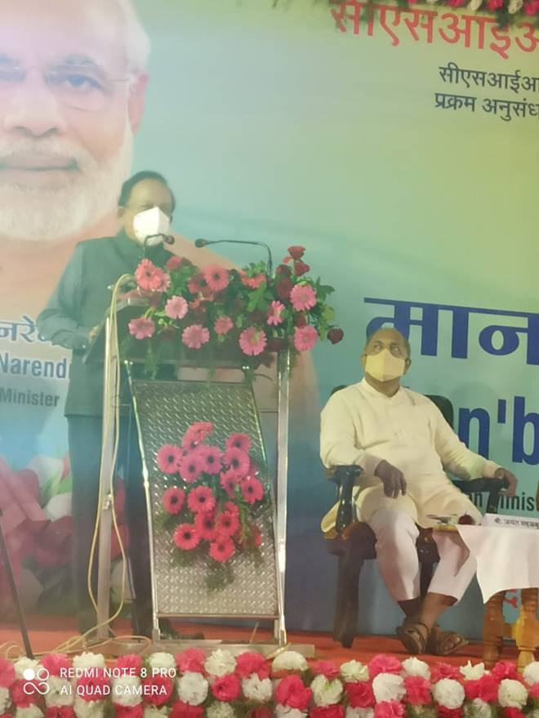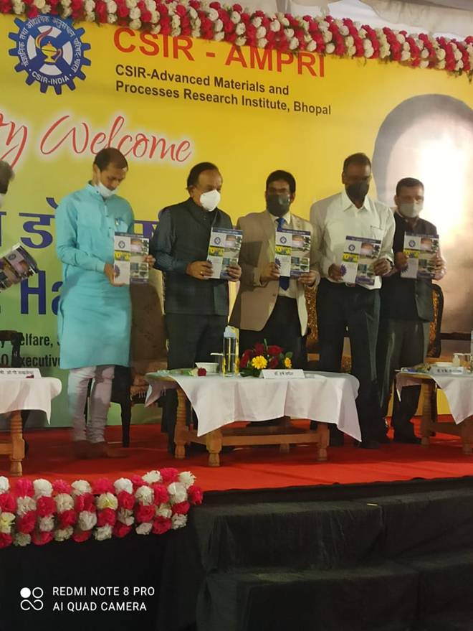
Please CLICK HERE for brief details about Multifunctional Bamboo Composite Material for Modern Housing and Structures (Annex B 1).

Please CLICK HERE for Brief Details about Analytical High-Resolution Transmission Electron Microscopy (HRTEM) Facility (Annex B 2).
Please CLICK HERE for details on CSIR-AMPRI (Annex B 3).
Please CLICK HERE for details on Makeshift Clinic for COVID-19 Patients (Annex B 4).
Please CLICK HERE for details of Support to Madhya Pradesh during COVID -19 as well as for management of various other diseases such as TB etc since 2014 (DOC-1).

Source
Press Information Bureau, 14 March, 2021

