Prime Minister to inaugurate the India International Science Festival-2020 tomorrow

Vice President to address the concluding session of IISF-2020 on December 25, 2020
“Scientists have shown and will show again that they can face any new emerging challenges”: Dr. Harsh Vardhan
The year 2020 may be aptly called as the Year of Science and Scientists :Dr. Harsh Vardhan
IISF-2020 to attempt Guinness records in five categories

The countdown to the 6th edition of India International Science Festival (IISF) has begun. This year’s mega science festival will take offon 22nd December with the inaugural address by the Prime Minister Shri Narendra Modi. The journey of IISF was started in the year 2015. “During the COVID situation, IISF-2020is being organized online and it is going to be the largest science festival in virtual environment”, said the Union Minister for Science & Technology, Earth Sciences and Health & Family Welfare, Dr. Harsh Vardhan in New Delhi today. He was addressing the curtain raiser press-conference on IISF-2020. He informed the media that while the inaugural address at the Festival will be made by the Prime Minister, Shri Narendra Modi, the concluding session of the Festival on December 25, 2020 will be addressed by the Vice-President Shri Venkaiah Naidu.

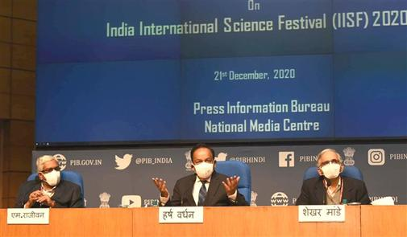
Dr. Harsh Vardhan highlighted that science and scientists have always risen to any challenge and elaborated how during the COVID-19 pandemic “Indian scientists rose to the occasion and within a short span of time created a large number of products ranging from sanitisers, face marks, PPE kits to ventilators and have gone on to discovering new drugs, vaccines and genome sequences of the COVID-19 virus”.

Dr Harsh Vardhnsaid thatscience in our country has made commendable strides and so it was thought that people at large should know and take pride inscientific developments and achievements of our country. “That is why, to highlight Indian science and scientists, it was thought in 2015 that India International Science Festivals should be held every year where all people can participate and celebrate science”, he said.

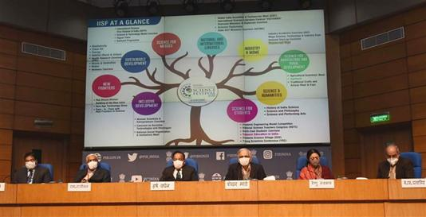

To a question about new strains of the prevailing COVID-19 virus, the Minister assured “Scientists have shown and will show again that they can face any new emerging challenges” and reminded them saying “Health issues also have become a Jan Andolan now and Indian people are aware of safeguarding themselves by taking appropriate precautions and adopting appropriate behaviour in such situations”.
Dr. Harsh Vardhan elaborated, “IISF is an annual event. It is an initiative of Govt. of India which is organized jointly by DST, DBT, MoEF, MoHWF and CSIR and in association with VijnanaBharati (VIBHA) as well as with support of a large number of other organisations. This year, IISF begins on 22nd December, 2020, the birthday of Srinivas Ramanujan, the world-renowned Indian mathematician, and culminates on 25th December, 2020, the birthday of our former Prime Minister of India Shri Atal Bihari Vajpayee”. “This science festival has become a science movement, a science “Jan Andolan’ to create awareness and inculcate scientific temper among the youth of the country and masses”, he said. “The theme for this year’s festival is ‘Science for Self-Reliant India and Global Welfare’ which will showcase the contribution of scientific and technological endeavours to realize the goal of Atmanirbhar Bharat Mission”, he added. In this science festival, a large number of students, teachers, scientists, researchers, entrepreneurs, artisans are going to participate.
Dr. Harsh Vardhanexplained that the virtual platform has opened up new avenues where scientists, youth, common people from India and abroad can enjoy and participate in the mega events in IISF-2020. He recalled the success of earlier IISF events, and said that despite the pandemic, “IISF-2020 may create new records in participation of people and newly added events, so much so that we may think of adding virtual platforms in future IISFs”. He also said that the year 2020 may be aptly called as “the year of Science and Scientists”.
In his welcome address, Dr. Shekhar C. Mande, DG-CSIR and Secretary-DSIR, highlighted the importance of the IISF 2020. He added that the total registration in this mega science festival has crossed the number of one lakh. He added “we are very encouraged by the participation of people in such a large number and it reflects that people are interested in the science festival and IISF has emerged as a major platform for taking science to society”.
Chief Coordinator and Director of the Nodal Institute (CSIR-NISTADS), Dr. RanjanaAggarwal, in her opening remarks spoke about the whole eventand said, “the virtual platform will help in connecting to the people who live even in the far-flung areasof the country. This is a unique festival whichconnects the society with science. In this festival, there are 41 different events in which 13 new events have been included and every section of the society will be enlightened in this science festival”.She informed the media that Guinness World Records (GWR) is a unique event of IISF and “this year we are trying to attempt Guinness records in five categories”. Dr. Aggarwal mentioned that in IISF 2020, events have been organized under 9 broad verticals: Science for Masses, Science for Students, New Frontiers, Industry and MSME, Science for Agriculture and Rural Development, Inclusive Development, Science and Humanities, National and International Linkages, and Sustainable Development.
ShriJayantSahasrabudhe, National Organising Secretary, VijananaBharati (VIBHA) said that the new events are thoughtfully designed as it not only brings the STI advancements to the forefront but also links it to Humanities such as History, Philosophy, Arts and Education. “Such events will add value to the festival, as it should highlight the rich tradition of Indian science that is evidenced in our ancient texts which includes the Vedas&Upanishads. Such events will also generate curiosity to pursue good science through the awareness of the great scientific discoveries and technological achievements which have been strength of ancient India”, he added.
On this occasion, Secretary MoES, Dr. Madhavan N. Rajeevan, Secretary DBT, Dr. RenuSwarup, Scientist ‘G’, DST, Dr. Sanjeev Varshney and other scientists were present.
Principal Director General, Press Information Bureau, Shri KuldeepDhatwalia informed about various outreach programmes carried out by PIB across the country to generate awareness about IISF-2020 and also mention that the Bureau has also built a microsite on PIB website on IISF-2020 giving detailed information.
IISF 2020 is being organized jointly by Council of Scientific and Industrial Research (CSIR), Department of Science and Technology (DST), Ministry of Earth Sciences, Department of Biotechnology (DBT), Indian Council of Medical Research (ICMR) in association with VijnanaBharati. The nodal institution for science festival this year is CSIR-National Institute of Science, Technology and Development Studies (NISTADS), New Delhi.

Detailed information is available on IISF website-www.scienceindiafest.org
And PIB website: pib.gov.in/iisf
Click here for PPT on IISF 2020

Source
Press Information Bureau, 21 December, 2020

