CSIR-Central Electrochemical Research Institute (CSIR-CECRI) working with Industry to Scale up Personal Protective Equipment
Digital training to make face masks by interested rural women

Under the present COVID-19 pandemic situation, in line with CSIR’s special efforts, its constituent lab CSIR-CECRI (Central Electrochemical Research Institute) at Karaikudi, Tamil Nadu, has come out with helping hands to reach out to the society through scientific service in mitigating COVID-19. In the current situation, Sanitizers, Hospital assisting Devices and Personal Protective Equipment (PPE) are essential. In that direction CSIR-CECRI prepared series of lab made PPEs that include Hand sanitizer solutions, as per the WHO recommendations (Iso-propanol 75%, Glycerol 1.45%, Hydrogen peroxide 0.125% plus lemongrass oil for fragrance), Hand wash solutions using coconut oil and Sodium hypochlorite based disinfectant solutions. These solutions were packed in containers, printed for instructions to use and distributed to the needy organizations at free of cost.

So far, around 350 Litres of Hand sanitizers, 250 Litres of Hand wash solutions and 1000 Litres of Hypo-disinfactants have been distributed. The beneficiaries include Karaikudi Municipal Corporation, Devakottai Municipal Corporation, Sivaganga Govt. Medical College Hospital, Govt. Hospital, Karaikudi, SP office Sivaganga and other police stations in and around Karaikudi, Taluk office and nearby Panchayat Unions and primary health centres from Sakkottai, Kottaiyur, R.S. Pattinam, Nerkuppai, few nationalized banks etc. CECRI plans to continue this distribution till the COVID-19 situation restores to normalcy.

In addition, CSIR-CECRI has recently started offering digital training to make face masks by interested rural women to help them as well as to cater to the needs of their neighbourhood. On the other hand, 3D printed face shield with reusable options has been in-house printed and gifted to the Dispensary staff of CSIR-CECRI to protect them effectively from sneeze, cough and aerosol communication of the patients.

CSIR-CECRI is tying up with industry to scale up the mass production and has partnered with a company 3D Lycan, Bangalore for Face Shield. CSIR-CECRI is now committed to arrive at a synergistically improved version of Face shield with antimicrobial efficiency within the shortest possible period. CSIR-CECRI is also transferring the technology of one of the popular CSIR-CECRI technologies on the electrochemical synthesis of hypo-chlorite (Disinfectant), This is transferred to an interested MSME for its mass production and supply as disinfectant spray for its wider deployment in public places, hospitals etc. In this way, CSIR-CECRI lives upto the expectations of the society and also rises to the occasion in fulfilling the needs of the society and the dreams of the great philanthropist, Dr. RM. Alagappa Chettiar, who has donated land and cash and was instrumental in establishing CSIR-CECRI in the heritage town of Karaikudi

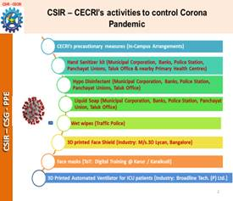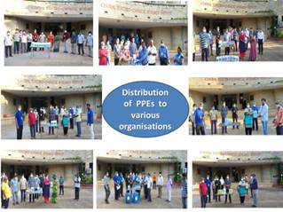

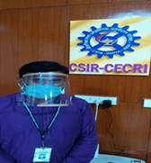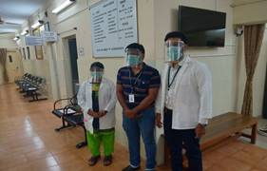

CSIR-Central Electrochemical Research Institute (CECRI), a premier research establishment under the aegis of Council of Scientific and Industrial Research (CSIR), New Delhi, focussing on a gamut of problems covering all facets of electrochemical science and technology: viz., Corrosion Science and Engineering, Electrochemical Power Sources, Electrochemical Materials Science, Electro-organic and Electro-inorganic Chemicals, Electrodics and Electrocatalysis, Electro-metallurgy, Electro Plating and Metal Finishing Technology. CSIR-CECRI's activities are directed towards the development of new and improved products and process as well as innovations in electrochemical science and technology. CSIR-CECRI runs several projects in collaboration with laboratories and private companies within and outside India.

CSIR-CECRI assists the Indian Industry by conducting surveys and undertaking consultancy projects. As part of its human resource development programme, CECRI runs a four-year B.Tech. course in Chemical & Electrochemical Engineering apart from encouraging Ph.D. scholars for their research under the Academy of Scientific and Innovative Research (AcSIR). Further, CSIR-CECRI is alive to societal obligations by way of offering ‘skill development' training and Jigyasa programs for the benefit of Indian youth.

Source

Press Information Bureau, 08 April, 2020

