Disinfection Walkway and Road Sanitizer Unit by CSIR-CMERI), Durgapur to fight COVID 19
In the wake of the Novel Coronavirus (COVID 19) wreaking havoc across the World, the Council of Scientific and Industrial Research (CSIR), has been stepping up efforts to deliver S&T solutions. One of the CSIR’s premier engineering lab based in Durgapur, CSIR-Central Mechanical Engineering Research Institute (CMERI) has developed technologies and products, which can help in countering the menacing virus.
The following are a few of the customized technologies which are the need of the hour:
Disinfection Walkways: The Disinfection Walkway can be considered to be one of the most comprehensive Disinfectant Delivery Systems available. The Walkway ensures maximum target coverage with minimum shadow area of an individual. The Disinfection Walkways can be deployed at multiple critical locations such as Isolation/Quarantine facilities, Mass Transit System Entry points, Medical Centres and any other location with a considerable amount of footfall.
Two variants of the Disinfection Walkway developed by CSIR-CMERI are:
- Pneumatic Variant Disinfection Walkway: This variant of Disinfection Walkway deploys Six Bar pressure Air Compressor to ensure optimum mist formation. The embedded sensors of the Walkway ensure that the operational time of the system can be varied within a range of 20 seconds to 40 seconds. Though the initial cost of this variant is relatively higher, the operating cost of this system is much less, owing to optimum usage of disinfectant in this system. This has been installed at CMERI and the dimensions of the Walkway at the CMERI Institute Main Gate are 2 metre height by 2.1 metre length and 1 metre width.
- Hydraulic Variant Disinfection Walkway: It deploys 1 hp pressurised motor High Velocity pump with necessary set up nozzles to ensure optimum mist formation. The initial cost of this variant is relatively lower. The embedded sensors of the Walkway ensure that the operational time of the system is just within a range of 20 seconds to 40 seconds. This variant of Disinfection Walkway has been installed at the CMERI Medical Centre.
National Science Centre, Delhi, Durgapur Municipal Corporation, and Ishwar Chandra High School, Durgapur have expressed interest in installing the Disinfectant Walkway.
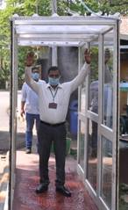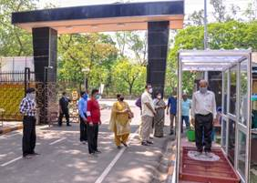
Disinfection Walkway Delegates from DMC visiting Disinfection Walkway

Road Sanitizer Unit:
The CSIR-CMERI Road Sanitizer Unit is a tractor-mounted Road Sanitizing System. This Road Sanitization unit can be effectively deployed in long stretches of highways, vicinity of toll plazas etc, where there is a massive volume of traffic and higher chances of infection spreading. It can also be deployed in Housing Complexes, Office Complexes, Sports Arenas, Apartment buildings etc.
The Road Sanitizer has a span of 16 feet, which uses 15 to 35 bars of pressure to ensure effective delivery of the sanitizer. 12 nozzles are used to ensure optimum radial coverage of sanitizer. The system utilizes a 2000 to 5000 litres tank with a pump of 22 LMP which can be used to sanitize a road stretch of up to 75 kms.

Asansol Municipal Corporation after Inspection of the Unit has placed an order for four such systems, of which one has already been delivered. Durgapur Municipal Corporation has also expressed interest for the Unit and procedural negotiations are under progress. Some MSMEs and Small Business Clusters have also expressed interest for the Unit and interactions are underway for the same.

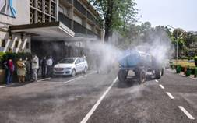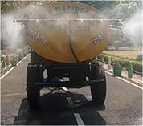
Demonstration of tractor operated road disinfection Spray System

Source

Press Information Bureau, 10 April, 2020

