DBT celebrates its 35th Foundation Day

DBT also organizes webinar/s on “35 years of Biotechnology Growth in India – An exciting journey”
BRITE (Biotechnology Research Innovation and Technology Excellence) Awards Given
The e-book "DBT Fights COVID- From Virus to Vaccine" showcasing initiatives and achievements of DBT in mitigation of COVID-19 pandemic, unveiled

The Department of Biotechnology (DBT) today celebrated its 35th Foundation Day. “The Department's role in the fight against COVID-19 pandemic is commendable. A special grant of Rs. 900 crore under Atmanirbhar Bharat 3.0 has been allocated to the Department for the COVID-SURAKSHA towards development of vaccines against COVID-19”, speaker at the function pointed out.
The function to celebrate the 35th Foundation Day of DBT was held through video-conferencing.Speakers highlighted that the Department is making tremendous efforts to make our country Atmanirbhar in the Biotechnology sector. “National Biomedical Resource Indigenisation consortium (NBRIC) being the classical example”, he said. “This platform aims to achieve self-reliance towards diagnostics, vaccines and therapeutics for COVID-19 and beyond”, they added.

Eminent speakers also lauded DBT for launching major missions in the Agri-Biotech Sector over past year towards the development of improved varieties of cereal crops. “BIOTECH KISAN programme of DBT has been implemented in 105 Aspirational districts and more than 50,000 farmers have been benefitted till date”, they informed.They also pointed out,“DBT-NGGF - National Genotyping and Genomics Facility- for advanced crop genomics technology and genotyping services to Public and Private Institutions has been established.Three improved maize hybrids have been developed by Enrichment of Nutritional Quality in Maize through Molecular Breeding”. It washighlighted that DBT has released“Guidelines for evaluation of nano-based agri-input and food products in India” released to push innovation in the agri-sector.

The participants emphasised,“Indian Biological Data Centre (IBDC) was established by DBT for deposition, storage, annotation and sharing of biological data generated in the country through extensive funding from various Government Organizations”. “Pan India Genome India was initiated for cataloguing the genetic variation in Indian population with a goal for whole genome sequencing and subsequent data analysis of 10,000 individuals”, said the speakers.

The celeberations also marked giving away of prestigious BRITE (Biotechnology Research Innovation and Technology Excellence) Awards in various categories.The winners werecongratulated by all “for receiving the Har Gobind Khorana- Innovative Young Biotechnologist Award (IYBA), Biotech Product, Process Development & Commercialisation Award (BPPDCA), TATA Innovation Fellowship (TIF), S. Ramachandran – National Bioscience Award for Career Development (SRC-NBACD) & J. Ammal- National Women Bio-scientist Award (JA-NWBA)”.

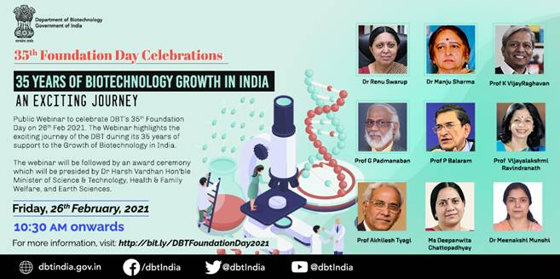

The e-book "DBT Fights COVID- From Virus to Vaccine" which showcases the initiatives and achievements of DBT in the mitigation of COVID-19 pandemic encompassing vaccines, diagnostics, biorepositories, therapeutics and genome analysis and other interventions, was also unveiled on the occasion.. (Please see attachment.)

Speaking on the occasion, Dr. Renu Swarup, Secretary, DBT, informed that the department had undertaken several reforms in the past one year and emphasised on the generation of biotech products, process and technologies for enhanced efficiency, productivity and cost effectiveness in Agriculture, Food and Nutritional Security, Affordable Healthcare, Environmental Safety, Clean Energy, Biofuel and Biomanufacturing.Dr. Renu Swarup, also informed that the Department through its various programmes has made immense contributions to the National Mission launched by Prime Minister-Swasth Bharat, Swachh Bharat, Startup India, Make In India and Digital India.

To mark theoccasion, DBT also organized webinar/s on “35 years of Biotechnology Growth in India – An exciting journey”. Dr. Manju Sharma, Former Secretary DBT wished DBT and all its institutions a bright future. Prof.VijayRaghavan, PSA to GoI and former Secretary DBT delivered the inaugural address. Eminent scientists like Prof. Padmanaban,IISc, Bangalore; Prof. Balaram,IISc, Bangalore;Prof. Akhilesh Tyagi,Former Director, DBT-NIPGR, New Delhi;Prof. Vijayalakshmi Ravindranath,Centre for Neuroscience, IISc, Bangalore; and Dr DwipanwitaChattopadhyay, Chairman & CEO at IKP Knowledge Park, Hyderabad; also spoke on the occasion.
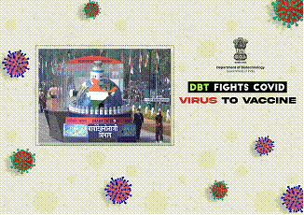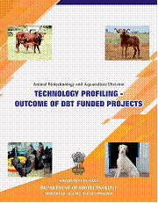

Source
Press Information Bureau, 27 February, 2021

