CCMB may soon come up with diagnostic kits for Covid-19

CCMB is also planning to culture the covid-19 virus

To combat Covid-19 pandemic, the World Health Organisation (WHO) insists that widescale “testing, testing, and testing” is the key as early diagnosis may help save lives. Aligning with the call of WHO, the Centre for Cellular and Molecular Biology (CCMB) is working overtime on the development of cost-effective and accurate diagnostic kits for wide distribution.
“We are helping our incubating companies; they have come out with ideas and we are supporting them. We are testing and validating the diagnostic kits proposed by them. We may come up with some good kits and it may take at least 2-3 weeks if everything goes well. Quality and accuracy of the kits are the most important things. If the kits give 100 percent results, then only they will be approved,” said Dr R K Mishra, Director, CCMB.

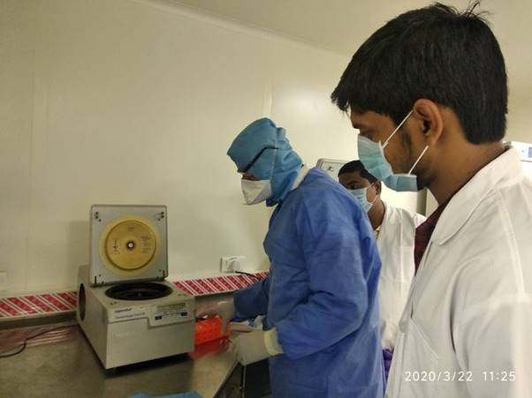
The organisation is also keeping in mind the cost. “Our estimate is that the test should be less than 1000 rupees. We are also thinking of kits which are as cheap as 400-500 rupees, but at present we cannot assure that, as it is a different route and all this needs more standardisation”, said Dr Mishra.
Further, CCMB is also planning to culture the covid-19 virus. Dr Mishra said that the institution has facilities for this and they have got the approvals from the government too, they are yet to receive sample and kits to initiate the culture. “In the meantime, our facilities are set and we are actually training people who are going for the testing in other recognised places in the city” he said. There are 5 government designated testing centres in Telangana state. CCMB has trained 25 people so that they can go and do the testing in these centres.
Some of the labs where the COVID-19 testing will be done include Nizam's Institute Of Medical Sciences (NIMS) Hydrabad, Gandhi Hospital, Osmania General Hospital, Sir Ronald Ross Institute of Tropical and Communicable Diseases or the Fever Hospital and the Warangal Hospital. The Centre for DNA Finger Printing and Diagnostics (CDFD) is also likely to be added to this group.
Vaccine and drug development are another aspect of fighting the virus. But as of now CCMB is neither working on the vaccine nor on the drug development. “We have no expertise for working on this. However, when the virus is being cultured, we will try to set up a system as it can be used for screening” said Dr Mishra. He told that may be CCMB’s sister organisation Indian Institute of Chemical Technology (IICT) is working for repurposing of drugs as making a new drug is a long-term process.

Source
Press Information Bureau, 25 March 2020

