Dr. Harsh Vardhan hails Scientific Contribution of DBT-ILS on its 32nd Foundation Day

DBT-ILS has excelled in application of science and technology for improving livelihoods of the tribal population: Dr. Harsh Vardhan
DGT-ILS is working to create a visible impact on lives and livelihoods of people of Odisha: Shri Dharmendra Pradhan
Dr Harsh Vardhan lays the foundation stone for the “Animal Challenge Study platform” at DBT-ILS; inaugurates Biorepository for COVID-19 clinical samples at ILS;dedicates ILS-IBSD partnership centreand launches the Himalayan Bioresources Mission
Dr. Harsh Vardhan, Union Minister for Health and Family Welfare, Science and Technology and Earth Sciences, today addressed through video conferencing the 32nd Foundation Day event of the Institute of Life Sciences, Bhubaneswar, an autonomous institute of Department of Biotechnology, and hailed its scientific achievements during the COVID-19 diagnostic and research.

Shri Dharmendra Pradhan, Union Minister for Petroleum and Natural Gas; Dr. Renu Swarup, Secretary, Department of Biotechnology; Dr. Ajay Parida, Director, DBT-ILS, Shri C. P. Goyal, Joint Secretary, DBT; Dr. Meenakshi Munshi, Advisor, DBT and other dignitaries were present on the occasion.

“The institute has sequenced around 500 viral genomes and established 17 virus cultures that will enable furthering the research and development efforts of COVID-19 in the coming days. DBT-ILS has excelled in application of science and technology for improving livelihoods of the tribal population,” said Dr. Harsh Vardhan. He also appreciated DBT-ILS for testing over 1,50,000 samples from across Odisha.

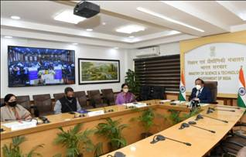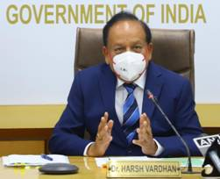
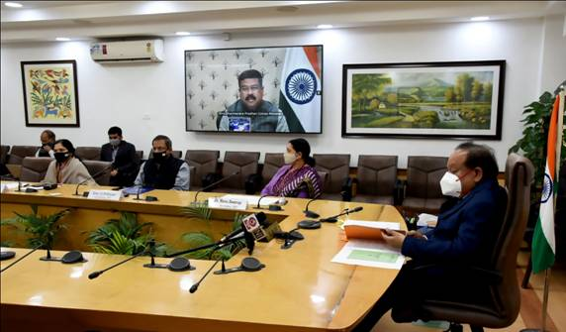

On the occasion, Shri Dharmendra Pradhan, Minister for Petroleum and Natural Gases, said that DBT-ILS is one of the premier institutions in Odisha and Eastern India and expressed satisfaction that ILS is working to create a visible impact on lives and livelihoods of the people of Odisha. The Minister further said that Odisha’s coastline has been in focus for Prime Minister Shri Narendra Modi’s vision of a blue economy. He requested Dr Harsh Vardhan that a Centre of Excellence on Marine Biotechnology at ILS be set up which will help unlock the true potential of a marine-led sustainable economic growth in Odisha.

Dr. Renu Swarup, Secretary, Department of Biotechnology, mentioned about the impressive progress made by DBT-ILS particularly in the area of tribal health and nutrition using multi-omics approach which will have far reaching implications. Dr. Ajay Parida, Director, DBT-ILS gave a detailed presentation on the work carried out in the area of research and development, COVID management, societal work as well as entrepreneurship development.

During the programme, Dr Harsh Vardhan also laid the foundation stone for the Animal Challenge Study platform at DBT-ILS for undertaking evaluation studies of potential drug and vaccine candidates. He inaugurated the Biorepository for the COVID-19 clinical samples at ILS that now holds more than 1000 samples of nasopharyngeal swabs, blood, urine and saliva etc from 202 COVID patients. The ILS-IBSD partnership centre that aims at skill and capacity development of scientific communities of North East region in the area of advanced biotechnology was also dedicated by the Minister. The Himalayan Bioresources Mission was launched Dr. Harsh Vardhan. This mission will carry out advanced research focusing on agriculture, horticulture, medicinal and aromatic plants, livestock and microbial resources, while taking up translational research for societal development.

Source
Press Information Bureau, 18 February, 2021

