BSIP joins hands with Govt of UP to combat COVID 19 in the state
The Government of India, along with the State Governments, has been relentlessly working for prevention, containment, and management of COVID-19. Birbal Sahni Institute of Palaeosciences (BSIP), an autonomous institute under the Department of Science & Technology (DST), joined hands with the Government of Uttar Pradesh to combat COVID-19 in the state. BSIP, as one of the five Central Government Research Institutes in Lucknow, took initial steps to start laboratory testing of COVID-19.

The availability of the ancient DNA BSL-2A laboratory in the Institute itself made it possible to prepare for testing immediately.

BSIP received the first batch of suspected COVID samples to test on 2nd May 2020, from district Chandauli. Since then, the lab is running 24x7 to test approximately 400 samples per day from various districts of Uttar Pradesh, as decided by the nodal authorities.

Till date, more than 12,000 samples have been tested, out of which about 400+ samples have been reported positive for SARS-CoV-2. This is highly commendable on the part of the BSIP, more so due to only limited resources and manpower.

Led by the Director BSIP, Dr. Vandana Prasad, the BSIP has constituted a team of dedicated scientists for efficient functioning. Drs Anupam Sharma, Pawan Govil, Kamlesh Kumar, Shailesh Agarwal, Vivesh Veer Kapoor, Santosh Pandey, and Niraj Rai. Dr. Niraj Rai is in-charge of the COVID-19 testing lab, very ably supported by Dr. Anuj Kumar Tyagi (Microbiologist) from GMC, Kannauj, and Satya Prakash, Dr. Varun Sharma, Dr. Indu Sharma, Nagarjuna P, Prashant, Harsh and Richa in analyzing and interpreting test results.

Team BSIP is thus contributing significantly to the fighting against COVID-19 pandemic. The Lucknow cluster of Research Institutes has been placed at the second position at the All-India level in Covid-19 testing.

“RT-PCR testing of Coronavirus at BSIP is a shining example of re-purposing of available resources with exceptional speed and scale despite many constraints thanks to the shared purpose, commitment, determination, and grit,” said Prof Ashutosh Sharma, Secretary, DST.

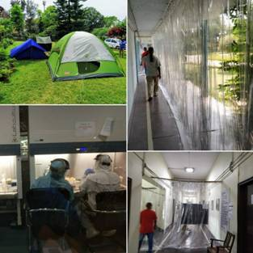
Photograph showing Temporary sample collection point, temporary corridor and testing lab

Source
Press Information Bureau, 07 July 2020

