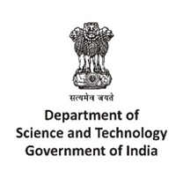 |  | 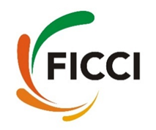
Technology Innovation Management and Entrepreneurship Information Service (TIME IS)
Idea to Investment Entrepreneurship Workshop
Venue- Hotel Marriott, Goa
10th August 2018

REGISTRATION FORM

I am interested in participating in the “Idea to Investment Entrepreneurship Workshop”
Name:

Designation:

Company/Organization:

Address:

Telephone:

Email:

Brief company profile:

Kindly email duly filled in registration form at timeis@ficci.com

